SECOND GRADE MATHEMATICS
UNIT 5 STANDARDS
Dear Parents,
As we shift to Common Core Standards, we want to make sure that you have an understanding of the mathematics your child will be learning this year. Below you will find the standards we will be learning in Unit Five. Each standard is in bold print and underlined and below it is an explanation with student examples. Your child is not learning math the way we did when we were in school, so hopefully this will assist you when you help your child at home. Please let your teacher know if you have any questions ☺

MCC2.G.1 Recognize and draw shapes having specified attributes, such as a given number of angles or a given number of equal faces. Identify triangles, quadrilaterals, pentagons, hexagons, and cubes.
This standard calls for students to identify (recognize) and draw shapes based on a given set of attributes. These include triangles, quadrilaterals (squares, rectangles, and trapezoids), pentagons, hexagons and cubes.

Example: Draw a closed shape that has five sides. What is the name of the shape?
Student 1
I drew a shape with 5 sides. It is called a pentagon.

MCC2.G.2 Partition a rectangle into rows and columns of same-size squares and count to find the total number of them.
This standard calls for students to partition a rectangle into squares (or square-like regions) and then determine the total number of squares.

Example: Split the rectangle into 2 rows and 4 columns. How many small squares did you make?

MCC2.G.3 Partition circles and rectangles into two, three, or four equal shares, describe the shares using the words halves, thirds, half of, a third of, etc., and describe the whole as two halves, three thirds, four fourths. Recognize that equal shares of identical wholes need not have the same shape.
This standard calls for students to partition (split) circles and rectangles into 2, 3 or 4 equal shares (regions). Students should be given ample experiences to explore this concept with paper strips and pictorial representations. Students should also work with the vocabulary terms halves, thirds, half of, third of, and fourth (or quarter) of. While students are working on this standard, teachers should help them to make the connection that a whole‖ is composed of two halves, three thirds, or four fourths.
This standard also addresses the idea that equal shares of identical wholes may not have the same shape.

Example: Divide each rectangle into fourths a different way.

MCC2.MD.10 Draw a picture graph and a bar graph (with single-unit scale) to represent a data set with up to four categories. Solve simple put-together, take-apart, and compare problems using information presented in a bar graph.
This standard calls for students to work with categorical data by organizing, representing and interpreting data. Students should have experiences posing a question with 4 possible responses and then work with the data that they collect.

Example: Students pose a question and the 4 possible responses. Which is your favorite flavor of ice cream: Chocolate, vanilla, strawberry, or cherry?
Students collect their data by using tallies or another way of keeping track. Students organize their data by totaling each category in a chart or table. Picture and bar graphs are introduced in 2nd Grade.

Flavor | Number of People
Chocolate | 12
Vanilla | 5
Strawberry | 6
Cherry | 9
Students display their data using a picture graph or bar graph using a single unit scale.
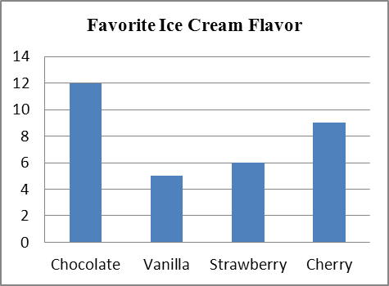 | represents 1 student
  Favorite Ice Cream Flavor
  Chocolate
  Vanilla
  Strawberry
  Cherry

